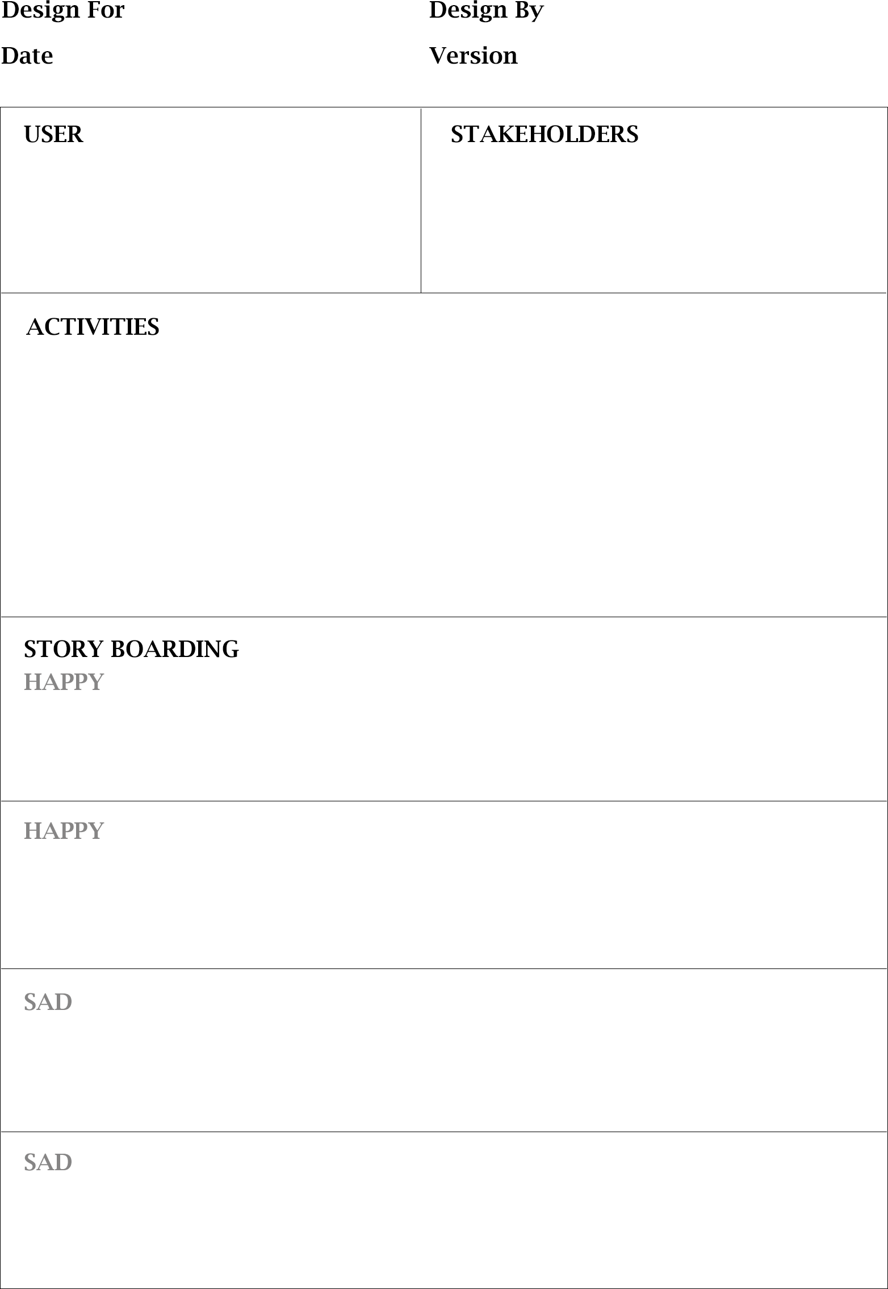

29/09/2020 1/1

HIGHER AUTHORITY

Once Investor wanted to invest their excess funds to any business so, he installed an application for finding businessman. Investor found out a businessman in that app. Eventually, Investor transferred money to the Businessman and after some time he realised that was a fraud Businessman, he lost their money because that application did not contain Identifications of both the users so, because of less security investor lost their money.

Once my friend started business of Pest-control, staring eight months was quite good for him but at some point of time his funding got over, so he was searching for money to grow his business. He found an investor by a third- party android application, in that application doesn’t have security for transaction. As Investor send money to my friend, due to lack of security my friend did not got money in his account.

My uncle Mr. Param Patel wanted to start a business of catering but he didn’t have much funds for business however, I suggested this application to him so, he found investor for their business and got enough funding for the same. Eventually, this application is useful in such kind of situations.

Once there was a businessman who had new idea for starting a business but he had not enough money to start a business but by using this application he could find investor for business investment, and he started a business. So, this application is beneficial in such kind of aspects.

COMPLAINT REGISTERING

GENERATING REPORT

HARDWARE MANAGEMENT

ACCESSING DETAILS

STORING EMPLOYEE DETAILS

BUSINESSMAN

INVESTOR

ENTREPRENEUR

ADMIN

EMPLOYEE